NIKITA CHOUDHARY

Roll no.-1901610100125

AIM: Write a program in c to perform bubble sort.

Program-

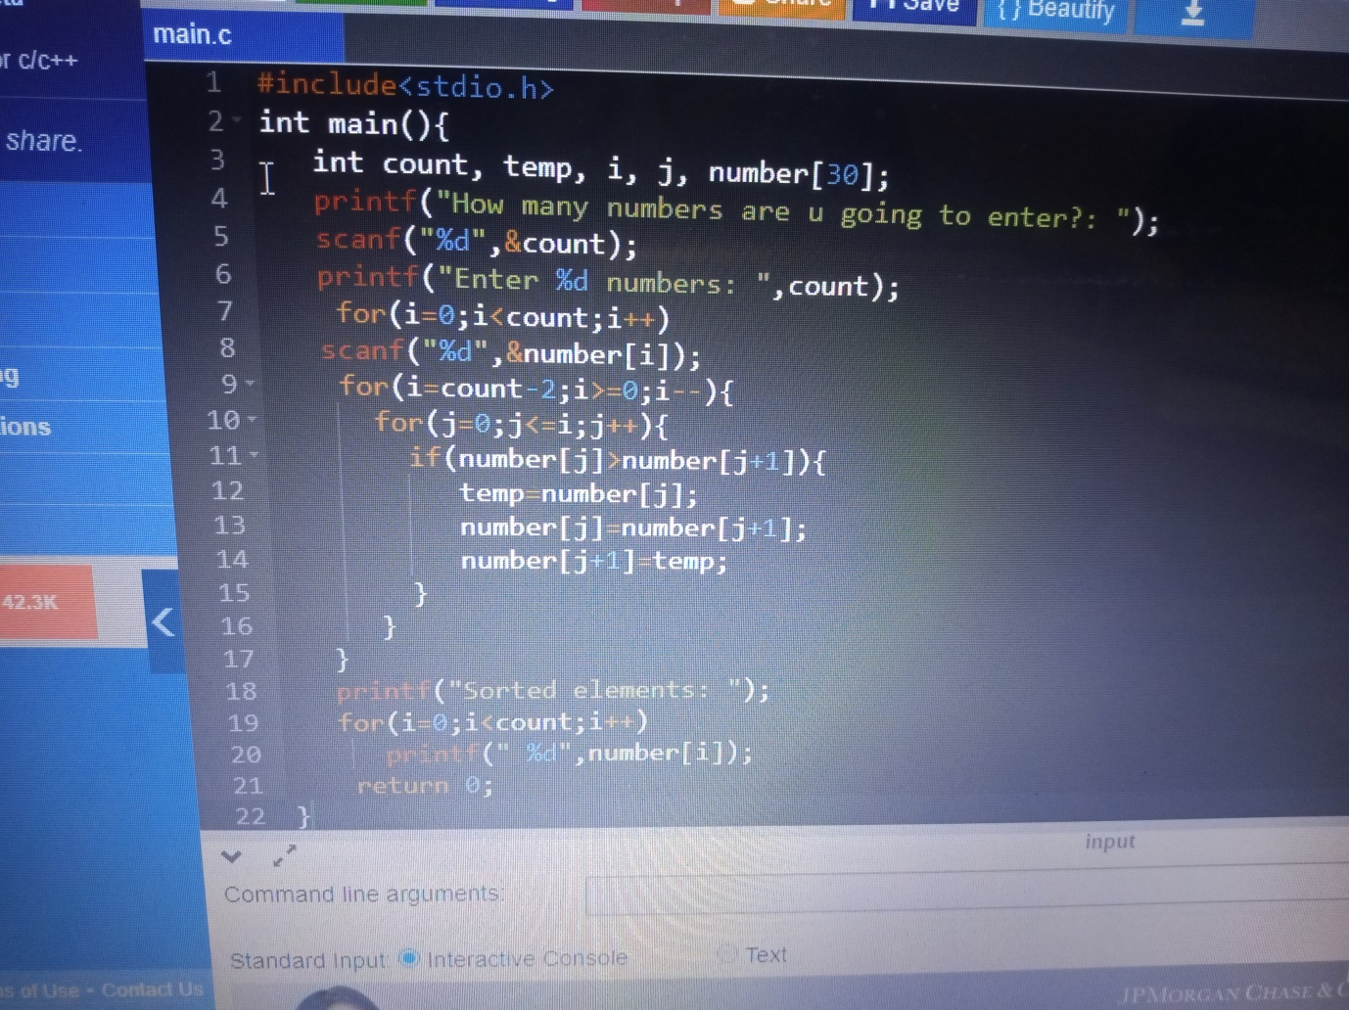

Output-

